Propaganda Poster Assignment in
WAR AND MILITARISM

Assignment:
Create your own original propaganda based on an idea in Unit 3. The poster must include both image(s) and text. The ad must also make clear use of at least one of the propaganda elements or techniques discussed in class. On the back of your finished product, you will need to indicate which method(s) you are using.
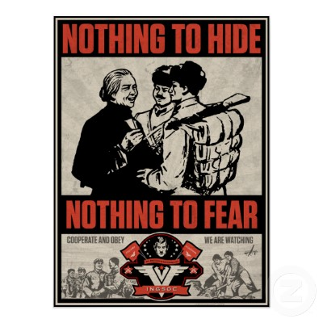
The best ads will contain messages which are clear and effectively conceived. Consider the examples shown in class – they are all aesthetically appealing – they make great use of the entire space in the poster – there is not a great deal of white, unused space. Your propaganda poster must also be consistent with the text.
You can hand-draw your poster, or use a program or app to design it but it must be made by you. See the rubric on the back of this page for evaluation.
Posters are due on _______________ with the rubric (back of this page).

