**Focus On Art and Dramatic Readings in ABOUT WAR**

**Introduction:** The Unit 4 galleries are based on the writing and artwork produced by children and youth who have direct experiences of war. These materials were produced in art workshops conducted by Children/Youth as Peacebuilders (CAP), a partner in this project.

Students are invited to do some of the same art activities and to compare their results with those of the youth whose work is featured in these galleries.



**Art Activities**

These art activities are modeled on those that CAP (Children and Youth as Peacebuilders) used with children who had direct experience of war, either as witnesses, victims or combatants. The CAP activities are issued as an invitation for participants to explore their memories and feelings.

If you have students who have experienced war, you may see some similarities between their art and the art presented in this gallery.

**Hands Art Exercise**

**Value:** A gentle introduction to the use of art techniques

**Materials:** Paper measuring about 8.5” x 11”, one sheet for each person

Pencils, markers, crayons, coloured pencils.

**Procedure:**

1. Hand out the sheets and pencils to all participants.
2. Participants are asked to make an outline of a hand or foot.
3. Each person is given a palette of acrylic paints (red, blue, yellow, white, black).

1. Facilitator shows them how they can mix these colours to create the colours they want.
2. Participants take time to create a design of colours on their hand/foot images as they like.

**Hands Art Writing Exercise**

**Note**: This is often done as a complementary activity to the “Hands and Feet” painting exercise.

**Value:** An easy exercise to encourage participants to think about themselves and their lives and to gain confidence in sharing anonymous, yet personal information.

**Materials:** 8.5” x 11” paper for each person

**Procedure:**

Ask each participant to complete the following statements with information about their lives. They are not required to put their name on the page.

* + - I am ___ years old.
    - My favourite food is __________________
    - My favourite time of day is____ because_____________________
    - One thing that is great about being a girl / boy / my gender is _____________________________________________________
    - What I like most about being my age is______________________

because_______________________________________________

* + - One thing that is difficult about being a girl / boy / my gender is _____________________________________________________
    - One thing that scares me is _______________________________
    - If my mother (father) were to describe me, she (he) would say this about me___________________________________________________.
    - One thing that happened in my life that I will never forget is _____________________________________________________
    - What I like most about school is _____________________________________________________
    - What I don’t like about school is_______________________­­___­­­­_
    - One thing that is really important to me is ___________________
    - One thing that makes me angry is__________________________
    - One thing that is really good in my life and makes me happy is _____________________________________________________
    - One thing that is really difficult in my life is _____________________________________________________
* One thing I worry about is________________________________
  + - My biggest happiness is__________________________________
    - My greatest hope and dream is____________________________

**“The Hand Gallery”**

**What is Important to Me:**

**“My family, to play the guitar and to live with my family in happiness.”**

**“I wish everyone could have the same opportunities, both boys and girls.”**

**“I think about my future – I want to have a profession.”**

**“I worry about the children in the street with no one.”**

**“For me happiness is sports.”**

**“I am a good person, I am a boy. But I am shy and short.”**

**“What is important to me – life, to be able to live.”**

**“For me the best time is the night because then my family is all together.”**

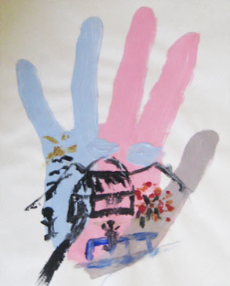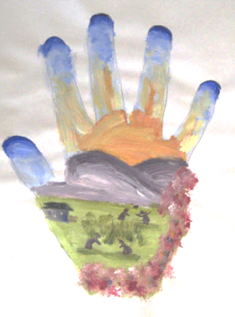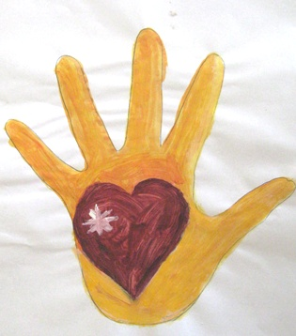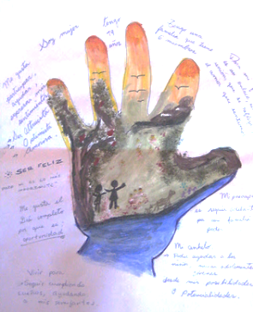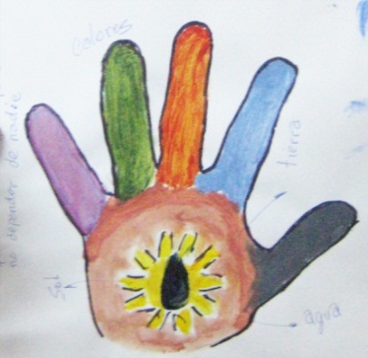**Paintings Produced in a workshop with indigenous youth in Bolivia**

**My Reflective Activity: The Colours of My Portrait**

**Value:** Information on young people’s feelings about themselves and their world.

**Materials:** Large paper (14” x 17”)

Acrylic paint and paint brushes (preferred)

Or: Crayons / coloured pencils

**Procedure:**

1. Engage the group in a discussion about the meaning of colour: how colours can signify different moods and feelings. Explain that there are also cultural differences about the ‘meaning’ of colour. For example, in some countries red is the colour for happiness (traditionally used for a bride’s dress in China); in others it means fear.
2. To begin the exercise, ask for a volunteer. She puts her head up against a sheet of paper (right or left profile). The facilitator draws the silhouette and shows it to everyone. This always creates a laugh as people are surprised with it. Ask the students to form groups of 2 or 3 and following your example, trace the profile of another in their group.
3. Ask each person to quietly think about the feelings inside themselves as well as their feelings about the world they live in. If you have soft music to play, that is always helpful to create a good atmosphere.
4. Then explain that in this activity they are going to create portraits of their feelings, using colour as codes to represent their feelings. This will include their feelings inside themselves as well as how the world “feels” to them.
5. If using acrylic paint, demonstrate how it can be mixed to create new shades. Provide each person with a small paper and dabs of paint in primary colours of red, blue, yellow as well as black and white. Organize water and paper for them to use to clean their brushes.
6. When the “Colours of My Portrait” exercise is complete, ask students to write a paragraph in which they explain what colours they used and what they reveal about their feelings.

**Reflective Exercise: My Body Remembers**

**Value:**  In this activity participants think about the pivotal events that have shaped their identities and view of the world.

**Materials:** Newsprint – large enough to accommodate the human silhouette.

Markers

**Procedure:**

1. Explain the purpose: to reflect on the impact of memories. Think about how our bodies store significant memories and the impact this has on our self-identity and relationships with others.
2. Lead the group through a relaxation exercise.
3. Ask each person to close her/his eyes and to think of responses to these statements. (Allow a short time after each one.)

* My eyes have seen…
* My ears have heard…
* My body has experienced…
* My heart has felt…
* My mind remembers...

1. Organize the students into groups of 4. Ask each group to create a silhouette of one person on the newsprint.
2. Ask the group to share some of their experiences in confidence with each other. Write some of these memories and impressions on the silhouette placing visual memories near the eyes, aural memories near the ears, etc.
3. Reassemble the group. Ask each small group to show their outlines and to give short presentations about their discussions. Engage the group in a discussion on the similarities and differences in the memories. Were most of the memories recent? Or from a particular age? Does gender have any impact on what we remember?

**Activity Related to *THE DARKNESS OF WAR***

1. **Write a collective poem modelled on *Our Memories.***

Study the opening poem “Our Memories”. After watching the slide show, write a collective poem in groups in response, based on your thoughts and emotions about this unit.

Prepare a choral reading of all of the poems.

1. **Circle of Viewpoints:**
2. View the first slide. Identify the different perspectives: the child, the mother, the father, the man who murdered them and the viewer. Who is affected but not present? Also include parts of the setting: an animal, a building, a tree, the earth: what is their contribution/meaning in this drawing?
3. Beginning with the perspective of the child. Imagine other points that might have been included, things the child (a girl) might have seen or experienced. Come up with a question / puzzle / or concern that you have from this viewpoint.
4. Organize the class into small groups and ask them to do the same exercise from one of the other points of view.
5. Share these viewpoints and discuss the questions that are raised by each perspective.
6. Choose another slide with several perspectives. Students can work with others who are interested in the same viewpoint and repeat the process.
7. Share the perspectives and the questions, puzzles, concerns that are raised.

**Tips:**

* Don’t accept superficial or comical responses. Push students’ thinking.
* If you teach multiple classes, consider typing up students’ responses from one class (without attribution) and give them to another class to sort according from high to low the level of thoughtfulness and insight the responses reveal.
* Have students share insights so that each viewpoint is thoroughly explored before moving on to the next. Begin with a strong viewpoint and then ask for different viewpoints or views of the events portrayed in the drawing/writing. Compare and contrast. Then invite someone to speak from a position more in between.

**Source:** The Circle of Viewpoints protocol is found in Church, M, Morrison, K. & Ritchhart, R. (2011). *Making Thinking Visible: How to Promote Engagement, Understanding and Independence for All Learners.* San Francisco: Jossey-Bass.

**Other Suggested Activities**:

1. Study slides six and seven and read the credits and information on the process of creating this art.Write a responsive report, identifying the changes between the two images and what they signify.
2. If any students have seen or directly experienced violence and have taken a road to recovery, perhaps they would be willing to share their experiences.

3. Return to the results of THINK-PUZZLE-EXPLORE.

Did you solve any of the puzzles while watching or refl**ec**ting on this gallery?

**Activity Related to *WHAT WAR IS LIKE and THE LIFE INSIDE***

1. **View the slide shows** ***What War is Like*** and ***The Life Inside*.**

What are the common themes? What did you learn? What are your questions?

1. **Direct students to develop dramatic readings to accompany the slide shows.** The statements and memories of the children will be delivered as dramatic readings, with only the slide (without the words) as a focus for the audience.

* Assign one group to present ***What War is Like****.* There are 15 statements in slides 2 to 16, so you will need 15 readers or a smaller number who will read more than one statement. **Note:** ALL readers should read slide 10 (“What I remember” together and have practised this. Reader #9, will be responsible for directing the discussion about these 4 pictures.

Explain that each of the students will:

* Memorize the statement(s) and practise delivery to ensure a powerful effect. See below for tips for successful dramatic readings.
* Study the art that accompanies the slide. Ask each presenter to prepare one or two questions about the art and be ready to lead a short discussion on these questions.
* Before the dramatic presentation, the teacher or a student will set up the text-less slide show provided in the link above.
* Students line up in the order of their slides and statements, standing off to the side so that the focus is on the slide. Turn off the lights.
* Each student delivers his or her dramatic statement from memory while the associated slide is projected.
* After the dramatic reading has taken place, view the slide show with the text, stopping at each slide. The student who was responsible for each slide will lead a short discussion by asking the questions s/he prepared.
* Assign another group to present ***The Life Inside.*** These slides are accompanied by longer statements that can be dramatically read, not memorized. There are 21 slides. Slides 1, 2, 6, 11, and 13 are very short and can be presented by the same reader. The other slides can be divided up among the available readers.

Explain that each student will:

* Practise reading his or her statement for powerful effect.
* Study the art that accompanies the slide. Prepare one or two questions about the art and be ready to lead a short discussion on it.
* Before the dramatic presentation, the teacher or a student will set up the text-less slide show found in the link.
* Students will line up in the order of their slides and statements, standing off to the side so that the focus is on the slide. Turn off the lights.
* Each student reads his or her dramatic statement while the associated slide is projected.
* After the dramatic reading has taken place, view the slide show with the text, stopping at each slide. The student who was responsible for each slide will lead a short discussion by asking the questions s/he prepared.

Invite each student to write a poem based on the slide that he shared. (Go to the Focus on Writing Poetry section of this unit.)

**Return to the results of** **THINK-PUZZLE-EXPLORE.**

Did you solve any of the puzzles while viewing and reflecting on this gallery?

**How to Successfully Deliver a Dramatic Reading**

Your goal is to assume the identity of the writer. You will communicate meaning and emotions to your listeners, using only your spoken words.

**Preparation:**

1. What is the dominant meaning and emotion that you wish to convey?
2. How are you going to communicate this with just your voice? Inflection! Raise your pitch when asking a question, expressing happiness and life. Lower your pitch to express seriousness, complete a thought or to ask an indirect question. *One strategy to figure this out is to read the sentences but replace the words with a sound such as mmm or ahhhh*
3. Where should you pause?
4. Are there words which you may not enunciate clearly?
5. Write cues regarding inflection, pauses and enunciation in the margin of your material to be read.
6. Practice reading aloud. Then tape your reading. You will likely notice slurred words, unintended pauses. Make notes, improve your cues, read it again to see how you are doing. Finally, read to a trial audience. Ask them what dominant meaning and emotion they heard. Was this what you intended?
7. **If you are reading your material (rather than delivering it from memory)** print the material in a big, clear font. The lighting may be weak, so reprint the material in a fourteen-point font or even bigger.

**Delivery:**

1. No gum. No accents. Stand straight.
2. Using a microphone? Rule of thumb: If this is a handheld microphone, keep the microphone an average distance from your mouth equal to the length of a thumb resting on your chin. If it is a clip-on mike, then don't worry about it. If there is a gooseneck microphone at a podium, the rule of thumb applies again.
3. Sore throat? Weak voice? Suck on a honey-flavoured cough drop before a reading to coat and soothe your throat. This way, you can put as much power into the work as you want.